La recette: RATATOUILLE
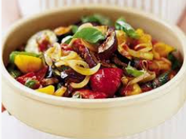
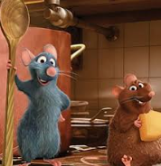
Ratatouille is a French dish: ‘rata’ is slang from the French army, meaning ‘chunky stew’ and ‘touiller’ means ‘to stir.
Here is a French recipe for Ratatouille. Can you translate it into English?
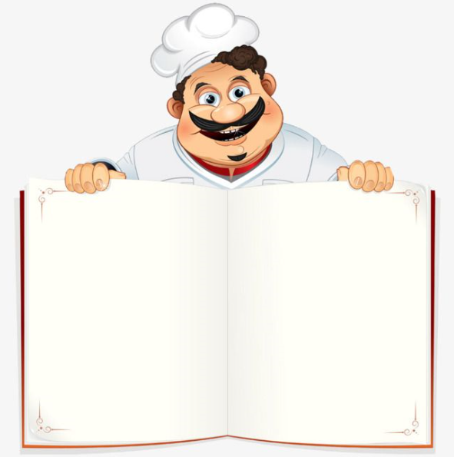

- 25cl d’huile d’olive
- 2 gousses d’ail
- 150g d’oignons
- 150g de poivrons jaunes
- 1kg de courgette
- 750g d’aubergine
- 600g de tomates
- Herbes de Provence
- Sel, Poivre

- Coupez l’ail, les oignons, les poivrons, l’aubergine et les tomates.
- Mettez les légumes dans un poêle avec l’huile d’olive, le sel et le poivre.
- Cuisinez pour environ 1 heure, remuez de temps en temps.
- Ajoutez les herbes de Provence.
- Servez.

Vocabulaire:
Ail = garlic
Poivrons = peppers
Coupez = cut
Mettez = put
Un poêle = a frying pan
Cuisinez = cook
Remuez = stir
Ajoutez = add
Try making it at home and send Madame
Kaler some pics to put on the website!
lisakaler@petite-etoile.co.uk

